Appendix 1 Homework Problems

Problem A1.1

Determine the x and y components of the force vector shown below.

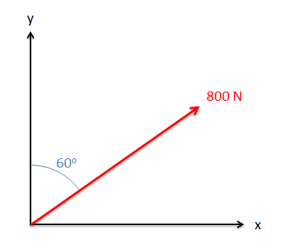

Solution: Fx=692.8 N, Fy=400N

Problem A1.2

Determine the x, y, and z components of the vector shown below.

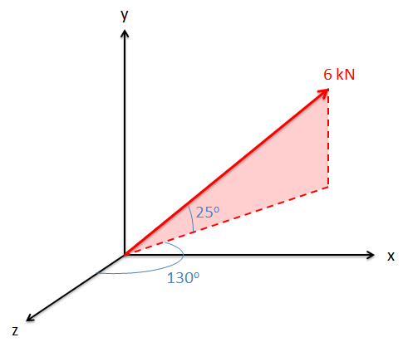

Solution: Fx=4.17 kN, Fy=2.54 kN, Fz=-3.50 kN

Problem A1.3

An 80 lb tension acts along a cable stretching from point O to point A. Based on the dimensions given, break the tension force shown into x, y, and z components.

Solution: Fx = 56.47 lbs, Fy = -37.64 lbs, Fz = 42.35 lbs

Problem A1.4

Determine the x and y components of the sum of the two vectors shown below.

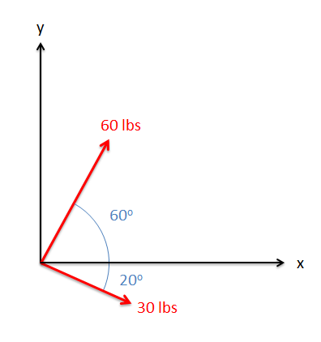

Solution: Ftotal = [58.2, 41.7] lbs

Problem A1.5

There are two forces acting on a barge as shown below (F1 and F2). The magnitude and direction of F1 is known, but the magnitude and direction of F2 is not. If the sum of the two forces is 600 N along the x-axis, what must the magnitude and direction of F2 be?

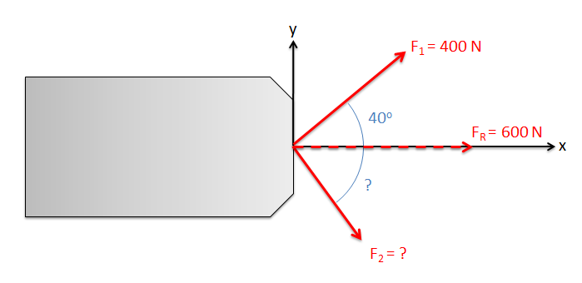

Solution: F2=390.3 N at 41.2o below the x axis